# FIT2001 Assignment 2 report

Submitted by: Team 26

Members:

1. Rui Qin, 30874157

2. Chenxin Zhang, 32444443

3. Timothy Correia-Paul, 29156548

4. Declan Wakefield, 30635535

**Assignment** **2 1**

Introduction 3

System Overview 3

2.1 Project description 3

2.2 System capabilities 3

2.3 Business benefits 4

Activity Diagram 5

Use Case Diagram 6

Domain Model Class Diagram 7

Conclusion 7

Appendix 7

## Introduction

Following the interview with Dan Summers regarding the to-be implemented business requirements of the Second Store system that Mr. Dan Summers’ detailed in his brief in A1 and interview on December 7; after research, discussion and planning the following report has been created to include these requirements. Below includes the System Overview, Activity Diagrams, Use Case Diagram and Domain Model Class Diagram which is for analysing the system requirements of the new automatic sales system. The whole report is based on the requirements the owner of the Secondo Store detailed in the prior conducted interviews.

## System Overview

### 2.1 Project description

Secondo is a second hand clothes selling firm that uses consignment to make a profit. However their sales system is all manual which causes low efficiency after the customer’s number is increased. The owner of the Secondo Store is looking forward to making the system automatically record the sale and customer information, also he wants to automatically manage the item information and emails. The new system will bring convenience and will look for the best way to support the customers, clients and employees of the business.

### 2.2 System capabilities

The following table shows the requirements including functional and non-functional

| **Functional** | **Non-Functional** |
| --- | --- |
| New clients can register an account | The system should clearly show the similar item information with a clear form |
| Current clients can login to their accounts to see their information and their item status and description | The system should provide a unique stock number while clients finish consignment |
| Current clients can put down a request to owner for delete their account | The system should be able to automatically classify the status of stock and put their consignment in its respective folder |
| Once the client searches an item, a list of similar items shows up with the selling price | The system should print the daily sales report with sale ID, stock quantity and sale price |
| The client can search particular item based on accounting and payment details | The system can show description of their stock item and the associated history |
| Client can upload a photo of clothes to a consignment form | The system can notify the customer that there cannot be a refund after client has been paid |
| The owner can update consignment through the system | The system scalability has been improved to handle the requests automatically to relieve unnecessary employee involvement |
| Clients can be paid through the system with their PayPal ID | Allow the owner to easily access and view the status of stock items |
| The owner can email clients requesting stock when the quantity is low | The user must be able to verify their account details in order to change personal information on their registered account |
| The owner can keep track of email notification while emails are sent to clients | Markdown history must be accessible by the owner |
| The system should automatically calculate the amount of money paid to clients after the item is sold | Additional duplicate users should be prevented when registering |
| The system can set up an email template and merge client data in order to send out personalised emails |  |

### 2.3 Business benefits

By making stock processes automated, the Secondo Store system will benefit the clients as well as the business employees by allowing them to manage these processes more efficiently while effectively presenting, benefiting all the users of the system.

Due to the automation process requiring several data gathering steps, the system can provide the business with methodical data management, allowing for any current customer or stock information to be accessed at any given point of time; ultimately contributing to the organisation of the information and the usability of the system.

The new implementations have also integrated a notification system which allows both clients and customers to receive emails regarding stock, deadlines and responses, allowing the business to cope with growth of additional order/sales while managing the processes associated with them automatically.

## Activity Diagram

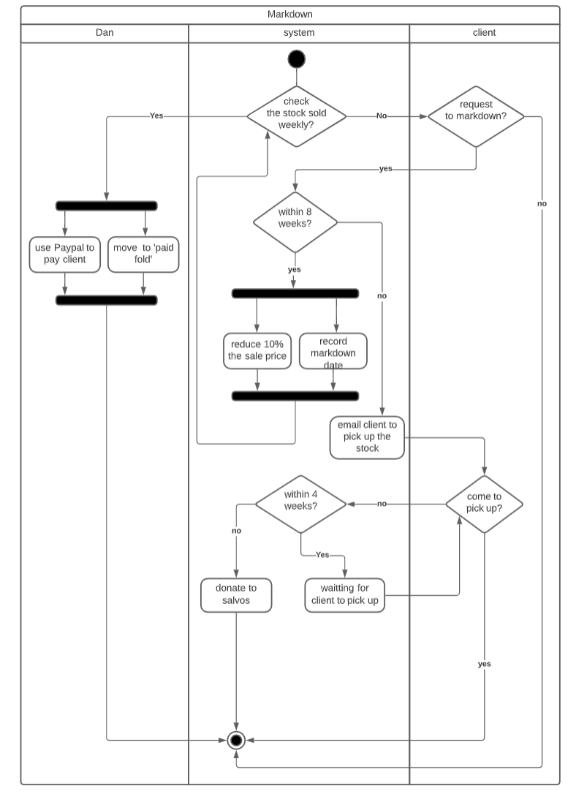

Assumption:

* We assume that the system checks whether the stock is sold every Monday.

## Use Case Diagram

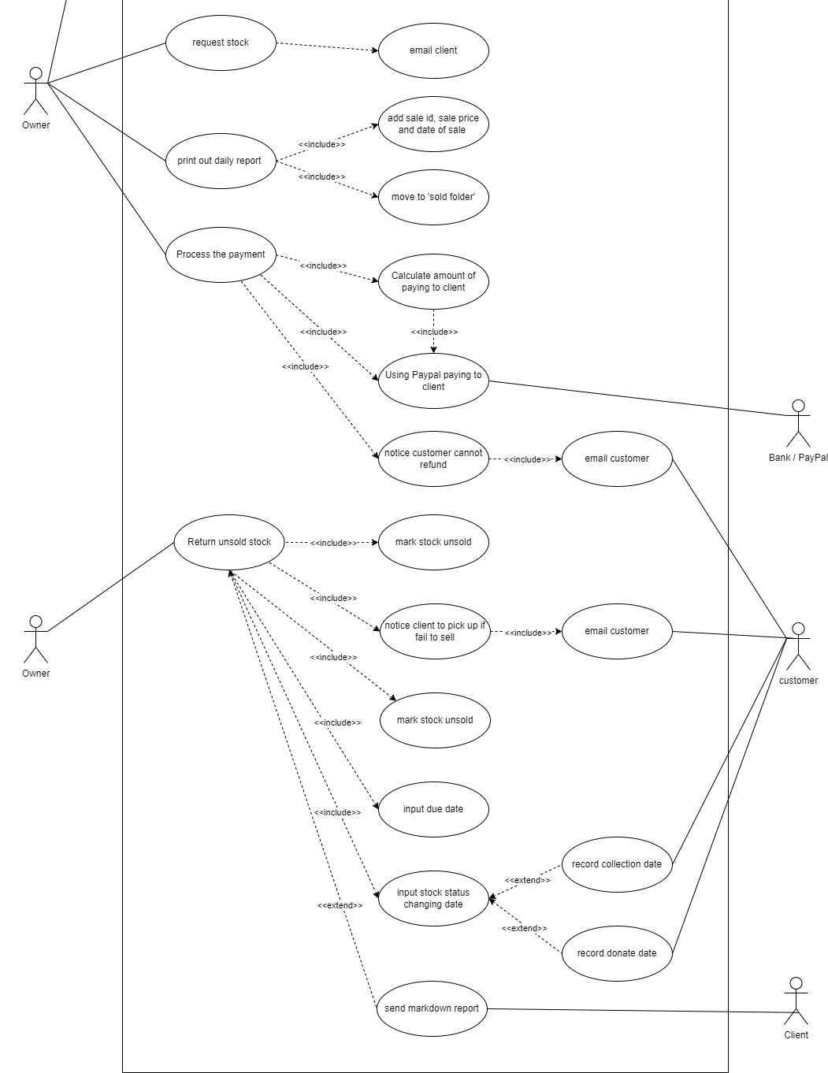

Assumption:

* We assume that an ID number will be automatically assigned when processing new stocks.

## Domain Model Class Diagram

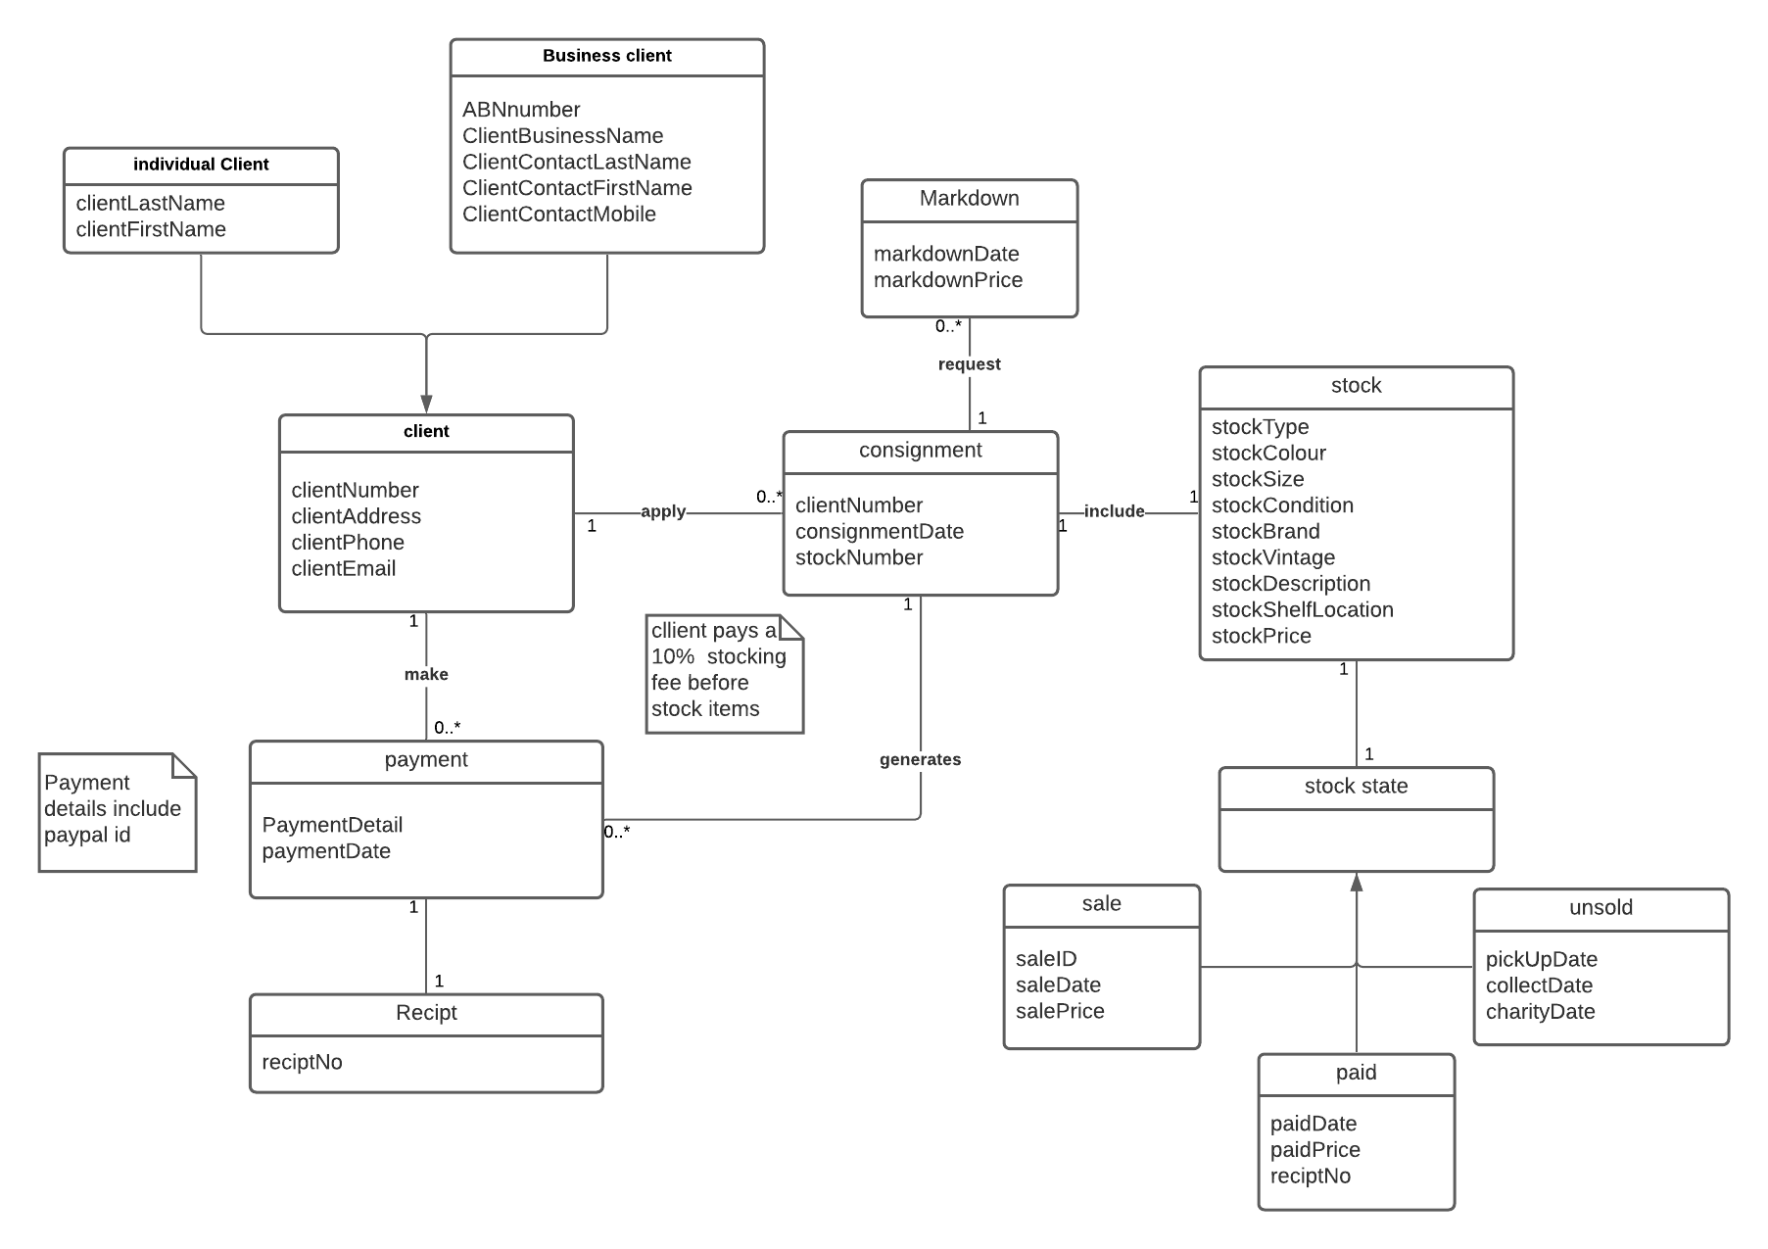

Assumption:

* Markdown can only occur on unsold items every Monday based on the markdown schedule.
* Assuming payment details include credit card and PayPal ID.

## Conclusion

After the completion of the diagrams and the review of the user story map drafted for the to-be implemented system with the extensively detailed requirements and functions wanted by Mr. Dan Summers taken into account; feedback has been utilised in order to ensure that the new changes to the system will fulfil said requirements and contribute to the future success of the business.

## Appendix

Activity and domain Diagram: [A2- domain diagram : Lucidchart](https://lucid.app/lucidchart/a183c89f-fb44-41fc-94ca-ae738c5dfb30/edit?invitationId=inv_8ef70902-36e6-4249-9319-b2840503c22d&page=0_0#)

Use Case diagram: https://drive.google.com/file/d/1xOyPpmhMkSYk4Gb1Ar1Mph7PZhuLSABn/view?usp=sharing